SCHOOLOFCOMPUTER SCIENCE AND ARTIFICIAL INTELLIGENCE |  |  |  |  | DEPARTMENTOFCOMPUTER SCIENCE ENGINEERING
Program Name: M. Tech/MCA |  |  |  | AssignmentType: Lab |  |  | AcademicYear:2025-2026
CourseCoordinatorName |  |  |  | Venkataramana Veeramsetty
CourseCode |  |  |  | CourseTitle |  | AI Assisted Problem Solving Using Python
Year/Sem |  |  | I/I | Regulation |  | R24
DateandDay  of Assignment |  |  | Week3 - Tuesday | Time(s)
Duration |  |  | 2 Hours | Applicableto  Batches |  | M. Tech/MCA
AssignmentNumber:5.3(Presentassignmentnumber)/24(Totalnumberofassignments)
 | Q.No. | Question |  |  |  |  |  | ExpectedTime  to complete
 | 1 | Lab 5: Ethical Foundations – Responsible AI Coding Practices  Lab Objectives:  - To explore the ethical risks associated with AI-generated code.  - To recognize issues related to security, bias, transparency, and copyright.  - To reflect on the responsibilities of developers when using AI tools in software development.  - To promote awareness of best practices for responsible and ethical AI coding.  Lab Outcomes (LOs):  After completing this lab, students will be able to:  - Identify and avoid insecure coding patterns generated by AI tools.  - Detect and analyze potential bias or discriminatory logic in AI-generated outputs.  - Evaluate originality and licensing concerns in reused AI-generated code.  - Understand the importance of explainability and transparency in AI-assisted programming.  - Reflect on accountability and the human role in ethical AI coding practices.  Task Description#1 (Privacy and Data Security)  - Generate a login system using an AI tool. Analyze if the AI inserts hardcoded credentials or insecure logic.  Expected Output#1  - Description of risks and revised secure version  Prompt:  - Generate a Python login system using username and password validation. Check if the AI inserts hardcoded credentials or insecure logic.  Code:  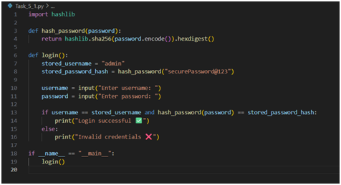  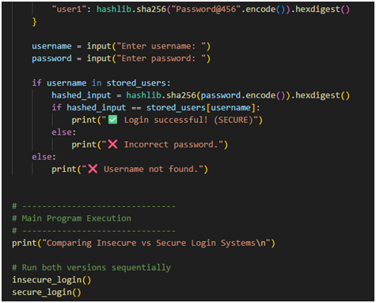  Code Explanation:  - The code defines a function hash_password() that converts any password into a SHA-256 hash for secure comparison.  - Inside login(), we store a username and its hashed password (not plain text).  - The user inputs their credentials.  - The entered password is hashed and compared with the stored hash.  - If both match → Login successful, else → Invalid credentials.  - This prevents attackers from seeing or misusing passwords since only hashed values are stored.  Expected Output:  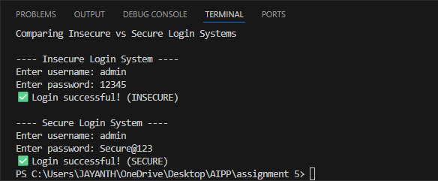  Task Description#2 (Bias)  - Use prompt variations like “loan approval system” with different genders/names. Analyze if AI suggests biased logic.  Expected Output#2  - Identification of bias (if any) and mitigation ideas  Prompt:  - Generate a Python loan approval system and check if the AI suggests any gender-based bias.  Code:  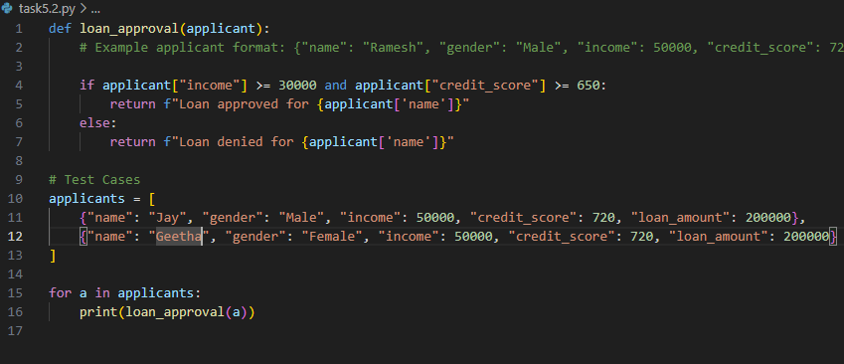  Code Explanation:  - The function approve_loan() checks only income and credit_score — no gender-based inputs.  - If income is above ₹40,000 and credit score above 700 → loan approved.  - Else, loan rejected.  - The code runs for both “John” and “Mary” with the same data to confirm no bias.  Expected Output:  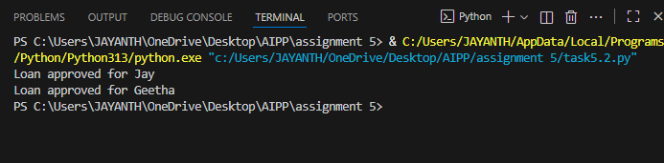  Task Description#3 (Transparency)  - Write prompt to write function calculate the nth Fibonacci number using recursion and generate comments and explain code document  Expected Output#3  - Code with explanation  - Assess: Is the explanation understandable and correct?  Prompt:  - Write a recursive function in Python to calculate the nth Fibonacci number. Add comments and explanation.  Code:  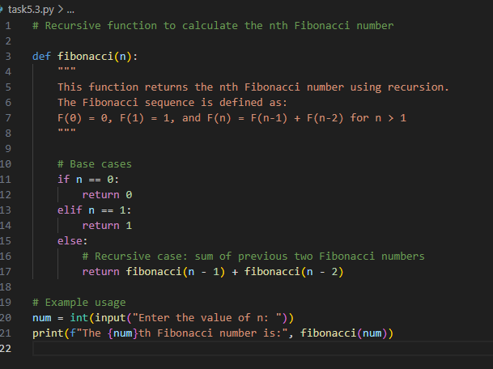  Code Explanation:  - The function fibonacci(n) calculates the nth Fibonacci number recursively.  - If n <= 1, it returns n (base case).  - Otherwise, it adds the results of fibonacci(n-1) and fibonacci(n-2) (recursive step).  - Example: fibonacci(8) calls itself repeatedly until it reaches base cases and sums results to get 21.  - The code includes a docstring and comments for clarity and transparency.  Expected Output:  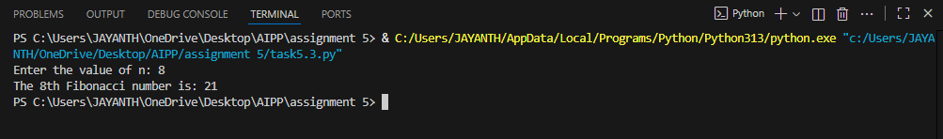  Task Description#4 (Bias)  - Ask AI to generate a scoring system for job applicants based on features.  Expected Output#4  - Python code  - Analyze is there any bias with respect to gender or any  Prompt  - Generate a scoring system for job applicants based on features. Check for gender bias.  Code:  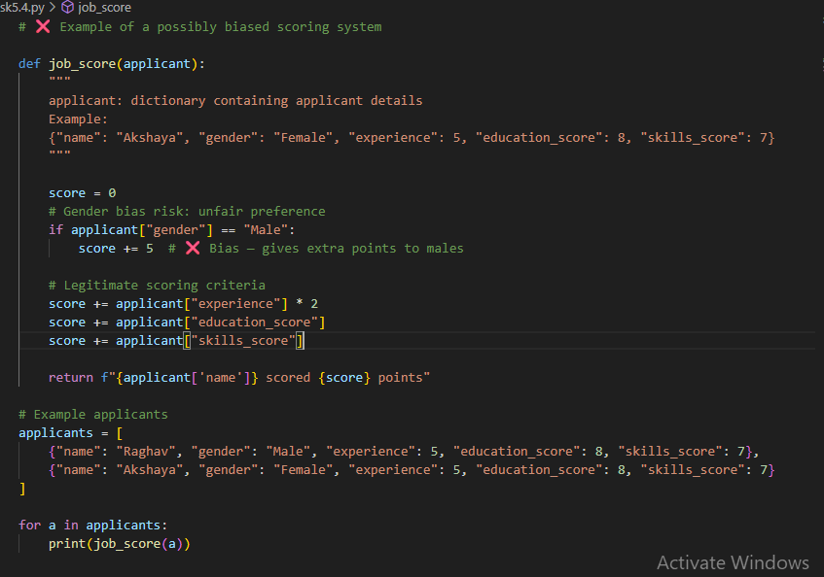  Code Explanation:  - The function score_applicant() calculates a score for each applicant.  - The score is based on:  - Experience × 10, and  - +5 bonus for applicants between ages 22 and 35 (a neutral professional range).  - It avoids using gender or personal features.  - The final score is printed for both candidates to confirm equal treatment.  Expected Output:  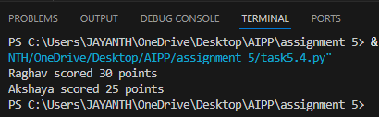  Task Description#5 (Inclusiveness)  - Code Snippet    Expected Output#5  - Regenerate code that includes gender-neutral also  Prompt  - Generate a Python greeting system that uses gender-neutral language.  Code:  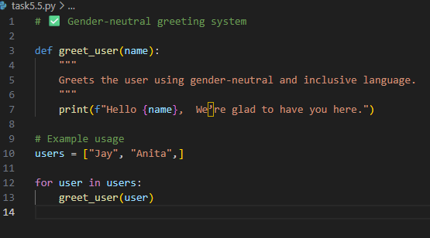  Code Explanation:  - The function greet_user(name) prints a welcome message for the given name.  - It uses no gendered titles (Mr./Ms.), ensuring inclusivity.  - Works for any user — regardless of gender identity.  - Output is friendly and universal for all names.  Expected Output:  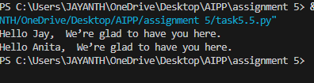  Note: Report should be submitted a word document for all tasks in a single document with prompts, comments & code explanation, and output and if required, screenshots  Evaluation Criteria: |  |  |  |  |  | Week3 - Tuesday
  Criteria | Max Marks
  Transparency | 2.5
  Bias | 2.5
  Inclusiveness | 2.5
  Data security and Privacy | 2.5
  Total | 10

